# **EXCURSIONS – DUBROVNIK**

The selection of excursions is sponsored by Nedbank.

* Once the excursion choice is made on the RSVP, such choice CANNOT be changed / swopped.
* Delegates can opt to have the time at leisure and not choose any excursion – this choice is to be indicated when completing the RSVP.
* Choose wisely!

**ATHENS**

**Option 1:** City walls

**Option 2:** City with museums

**Option 3:** Game of Thrones

**Option 4:** Kayaking

**Option 1: Dubrovnik – City walls**

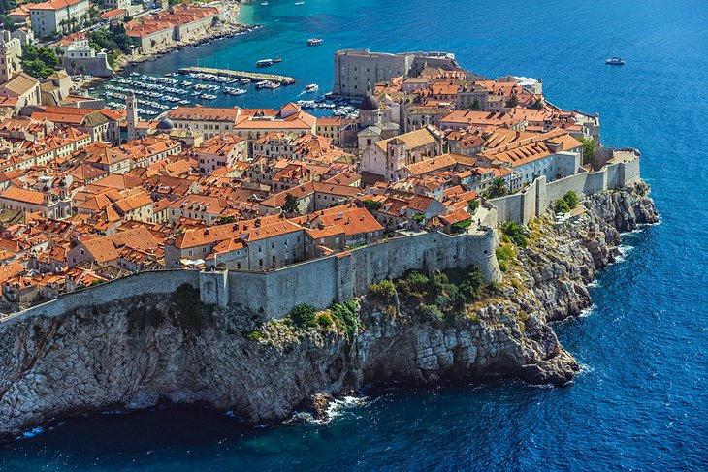 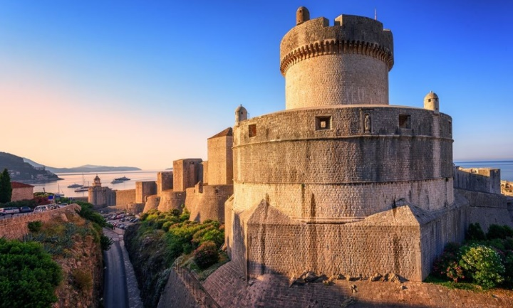

Today’s size of the Dubrovnik walls was shaped in the 13th century. The 1,940m-long walls of Dubrovnik are extraordinarily well preserved, and along with them, the ambiance of an authentic medieval town.

During the tour you'll have a bird’s-eye view over bustling life in the city and the glorious Adriatic Sea surrounding it.

Visit sea side of the city walls (cca 1 hour), and continue to explore the city.

Refreshement will be offered on city walls.

The tour around the city walls can be combined with 1 or 2 museums, to round up a real picture Dubrovnik’s beauty.

**Itinerary**

* **09:45 Meet at the hotel’s lobby with our English speaking guide. Departure by bus to the Old Town**
* **10:00 Guided visit tour of City walls – walk on the sea side**
* **10:45 refreshment on the City walls**
* **11:30 coming to the Old Town – walking tour, seeing the attractions from the outside like: st. Blaise’s church, Sponza, Dubrovnik Cathedral**
* **13:00 Lunch at restaurant Poklisar**

**Fitness Level**

Level 2 Moderate. There are stairs to reach City walls

**Travelling time**   
Bus transfer from hotel to Old City 15 minutes

**Additional Information**  
Don’t forget: comfortable clothes and walking shoes.

**Option 2: Dubrovnik – Old City with museums**

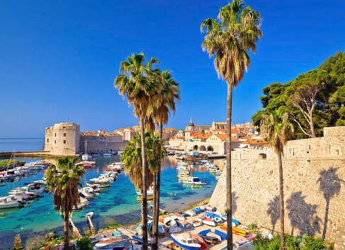 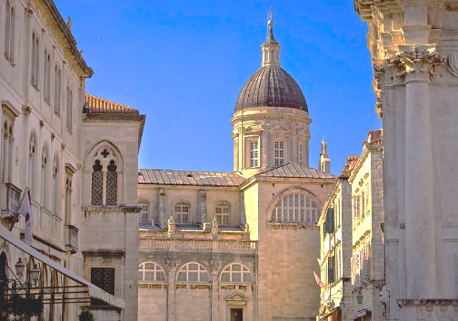 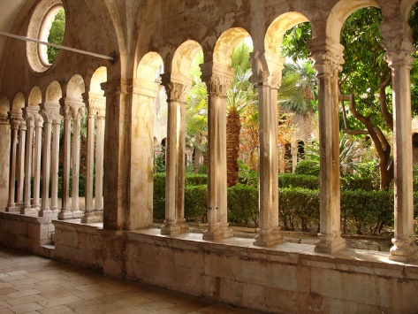

The 'Pearl of the Adriatic', on the Dalmatian coast, was an important Mediterranean Sea power from the 13th century onwards. Although severely damaged by an earthquake in 1667, Dubrovnik managed to preserve its beautiful Gothic, Renaissance and Baroque churches, monasteries, palaces, and fountains.

A tour 2of the world’s second most frequented open-air museum will definitely take your breath away.

With your guide you can visit the museums of Dubrovnik to find out where the Rector of the glorious Dubrovnik Republic used to live; which sailing ships formed the Republic’s powerful fleet that traveled all around the world and made Dubrovnik merchants famous; learn about the medieval grain storage systems; or shop for hand-made traditional recipe ointments at the second oldest pharmacy in the world and the oldest one still in operation.

The visit takes up to 3hrs max.

**Itinerary**

* **09:45 Meet at the hotel’s lobby with our English speaking guide. Departure by bus to the Old Town**
* **10:00 arrival to Pile gate, go to the Franciscan museum**
* **10:15 coming to the Franciscan monestary, explore the museum with the guide**
* **11h00 continue with the tour**
* **11:45 stroll down Stradun street – see from the outside famous monuments: church st. Blaise, Cathedral, Rector’s palace, Sponza**
* **13:00 lunch at restaurant Poklisar**

**Fitness Level**

Level 1 Easy. Must be able to walk comfortably. There is an uphill incline, as well as steps to the entrance of the Acropolis.

**Travelling Time**  
bus transfer from hotel to Pile gate (15 minutes)

**Additional Information**  
Don’t forget: casual clothing, sunscreen, sunglasses, comfortable walking shoes.

**Option 3: Dubrovnik – Game of Thrones**

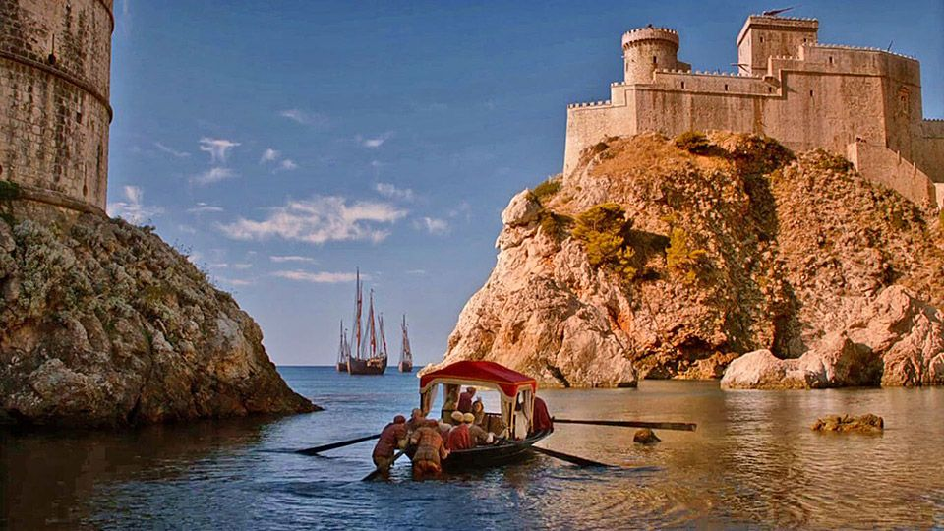 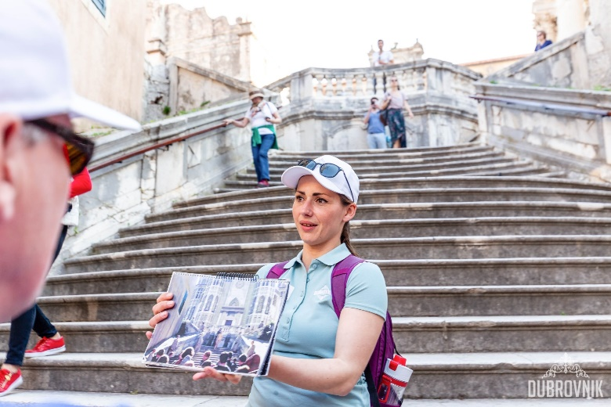

Dubrovnik was the main filming location in Croatia for King's Landing, a fictional city in Game of Thrones, the famous television series based on the series of fantasy novels “A Song of Ice and Fire” and distributed by HBO.

Discover all the amazing locations in Dubrovnik where the Game of Thrones scenes where filmed. The tour can include a visit of the famous Lovrijenac fort, the city walls and island Lokrum.

There is a wide choice of 16 filming locations is the Old City or it’s vicinity, like the Island of Lokrum (10min from the Old town), as an outside location where some of the scenes were filmed.

Passing the filming locations with a licensed guide who will give you an introduction od Dubrovnik’s history and walk you through these scenes, will create unforgettable memories of our beautiful Pearl of Adriatic.

**Itinerary**

* **09:45 Meet at the hotel’s lobby with our English speaking guide. Departure by bus to the Old Town**
* **10:00 arrival to Pile gate, go to the fortress of Lovrijenac**
* **10:30 walking through city of Dubrovnik, towards Old City port**
* **11:30 embark the boat to the island of Lokrum**
* **11:45 arrival to Lokrum – explore the island, visit GOT Throne**
* **12:45 return to Old City port**
* **13:00 lunch at restaurant Poklisar**

**Fitness Level**

Level 3 Moderate. There are stairs to reach fortress of Lovrijenac (200 stairs)

**Travelling Time**  
bus transfer from hotel to Pile gate (15 minutes)

**Additional Information**  
Don’t forget: casual clothing, sunscreen, sunglasses, comfortable walking shoes.

# 

**Option 4: Dubrovnik – Kayaking around the city walls**

 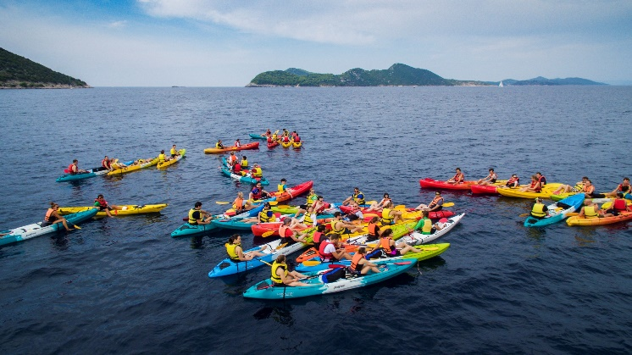

Warm and calm turquoise sea, dramatic scenery, hidden caves and beaches await on this kayaking tour. The kayaks are mostly double seaters, all the participants are given life jackets and a safety briefing before departing from the beach.

Morning tours are the most calm, you can have your peace and get a killer tan while exploring the sea around Dubrovnik.

If you don’t mind other kayakers on the sea and on the beaches, you can opt for an afternoon tour and see for yourself why Dubrovnik sunsets are famous across the world.

**Itinerary**

* **09:45 Meet at the hotel’s lobby with our English speaking guide. Departure by bus to the Old Town**
* **10:00 arrival to Ploče gate, go to the Banje beach where the sea kayaking is starting**
* **10:15 arrival to Banje beach – instructions**
* **10:30 start with kayaking**
* **12:30 return to Banje beach**
* **12:45 walk to the restaurant Poklisar**
* **13:00 lunch at restaurant Poklisar**

**Fitness Level**

Level 2 Moderate.

**Travelling Time**  
bus transfer from hotel to Ploče gate (15 minutes)

**Additional Information**  
Don’t forget: casual clothing, sunscreen, sunglasses, comfortable walking shoes, clothes to change to, towel

**Option 5: Dubrovnik – Elaphiti islands**

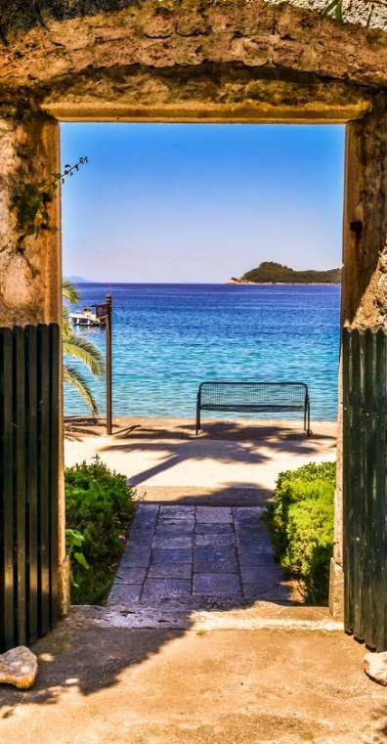 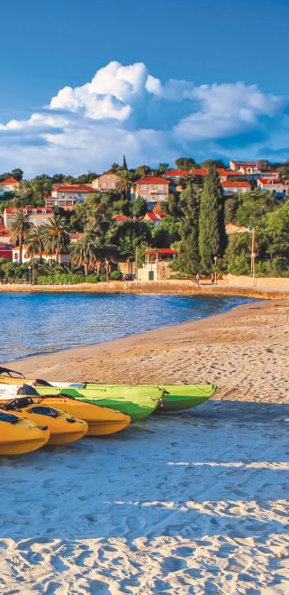 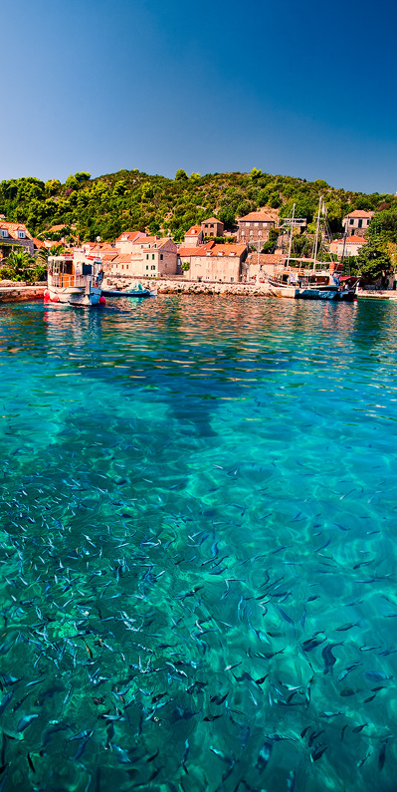

The archipelago of Elaphiti islands is just 30 minutes by boat from Dubrovnik and it consists of 8 islands, only three of which are inhabited. The islands are covered with pine forests and they will allow you to discover charming villages and idyllic bays.

The short boat ride discovering our coastline full of pine and cypress trees is the only thing keeping you from sailing between the islands of Koločep, Lopud and Šipan.

Departure and return points are usually in the commercial port of Gruž.

Transfer by bus from the hotel is 15 min max.

Departure from Dubrovnik old city can be organized on request.

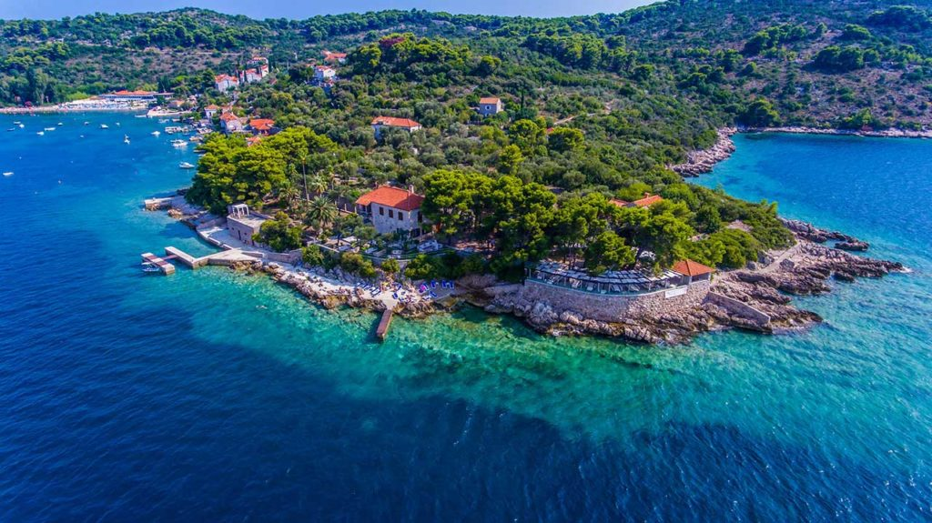

Villa ROSE is a spectacular location nestled at the tip of Donje Čelo Bay, in a completely private setting that exudes a sense of serenity and calmness found only in undisturbed nature.

It is said to be one of the most stunning spots on the Adriatic coast, with an equally excellent menu.

**Itinerary**

* **09:45 Meet at the hotel’s lobby with our English speaking guide. Departure by bus to the commercial port of Gruž**
* **10:00 arrival to Gruž, embark the boat**
* **10:10 departure from Gruž**
* **11:10 arrival to island of Lopud, free time on the beach & exploring**
* **12:30 departure from Lopud towards Koločep**
* **12:55 arrival to Koločep, Villa Rose**
* **13:00 lunch at restaurant Villa Rose**
* **After lunch free time**
* **16:00 departure towards Gruž**
* **16:45 arrival to Gruž, transfer to hotel**
* **17:00 arrival to hotel**

**Fitness Level**

Level 1 easy

**Travelling Time**  
bus transfer from hotel to Gruž port (15 minutes)

**Additional Information**  
Don’t forget: casual clothing, sunscreen, sunglasses, comfortable walking shoes, clothes to change to, towel